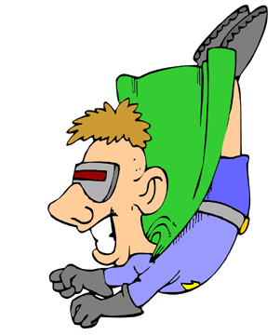

“I like vending machines, because snacks are better when they fall. If I buy a candy bar at the store, oftentimes I will drop it so that is achieves its maximum flavor potential.”

- Mitch Hedberg